Frontend Engineering Challenge: Interactive Calendar Component
Objective: Your task is to build a polished, interactive React/Next JS component inspired by the provided reference image. We want to see your ability to translate a static design concept into a highly functional, responsive, and user-friendly web component.
The Inspiration: Please review the attached reference image of the wall calendar. Notice the clean layout, the visual hierarchy between the imagery and the dates, and the integrated notes section. Your initial component should be styled to emulate this physical wall calendar aesthetic, featuring a prominent image at the top or side that serves as the visual anchor for the dates below. Use this as your creative starting point.
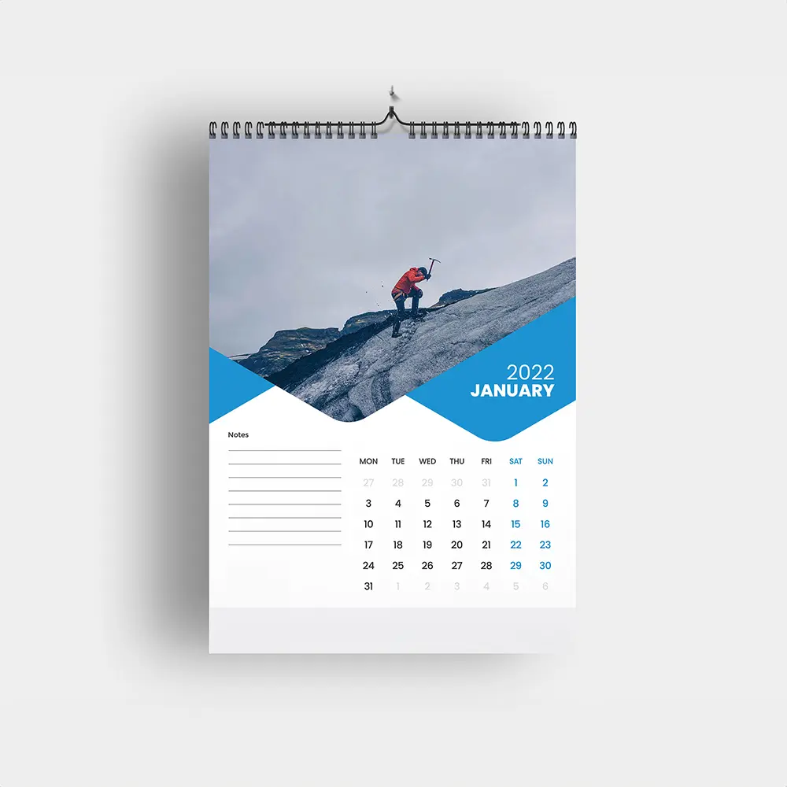
🛠 Core Requirements
Your component must include the following baseline features:
- Wall Calendar Aesthetic: The UI must resemble a physical wall calendar. This includes a dedicated space for a hero image that pairs with the current month's grid, maintaining a balance between form and function.
- Day Range Selector: Users should be able to select a start date and an end date across the calendar grid. Include clear visual states for the start date, the end date, and the days in between.
- Integrated Notes Section: Implement a functional notes area. This could allow users to jot down general memos for the month, or attach specific notes to their selected date range or date.
- Fully Responsive Design: The component must adapt flawlessly to different screen sizes.
  - Desktop: Consider a layout that honors the spatial arrangement of the inspiration image (e.g., side-by-side or clearly segmented panels).
  - Mobile: The layout must gracefully collapse (e.g., stacked vertically) while keeping the date selection and notes entirely usable on a touch screen.
✨ Creative Liberty (Stand Out!)
The core requirements are just the baseline. We highly encourage you to be creative and add extra features that showcase your product sense and technical skills (e.g., "flipping" animations, theme switching based on the image, or holiday markers).
📦 Submission Guidelines
To evaluate your work efficiently, please provide the following:
- Source Code: A link to your public GitHub/GitLab repository containing the project. Include a brief README.md explaining your choices and how to run the project locally.
- Video Demonstration (Required): Attach a short screen recording (or a link to a Loom/YouTube video) walking through the functioning component. Be sure to demonstrate the day range selection, the notes feature, and how the component responds to mobile and desktop screen sizes.
- Live Demo (Optional but recommended): A link to a deployed version of your component (Vercel, Netlify, GitHub Pages, etc.).
Evaluation Criteria & Scope:
- Strictly Frontend: This assessment focuses entirely on your frontend engineering skills. Please do not waste time developing a backend, database, or API. If your application requires data persistence, simply use client-side solutions like localStorage, sessionStorage, or static mock data.
- What We Look For: We will be closely evaluating your code quality, component architecture, CSS/styling implementation, state management, attention to UX/UI details, and how well you handle responsive design constraints.
Good luck, and have fun building!

